Assignment - 5
1. Write a query that will give you all orders for more
than Rs. 1,000.

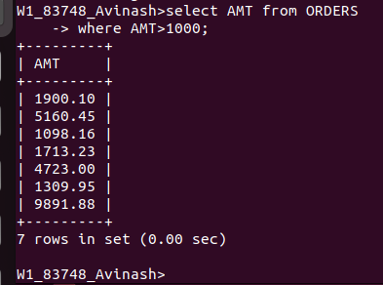

3. Write a query on the Customers table whose output will exclude all
customers with a rating <= 100, unless they are located in Rome.

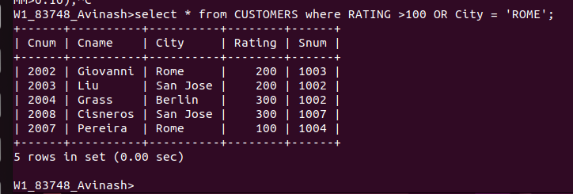

4. What will be the output from the following query?
Select * from Orders
where (amt < 1000 OR
NOT (odate = ‘1990-10-03’
AND cnum > 2003));

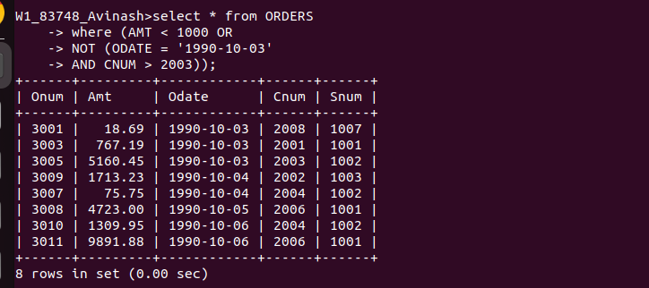

5. What will be the output of the following query?
Select * from Orders
where NOT ((odate = ‘1990-10-03’ OR snum
>1006) AND amt >= 1500);

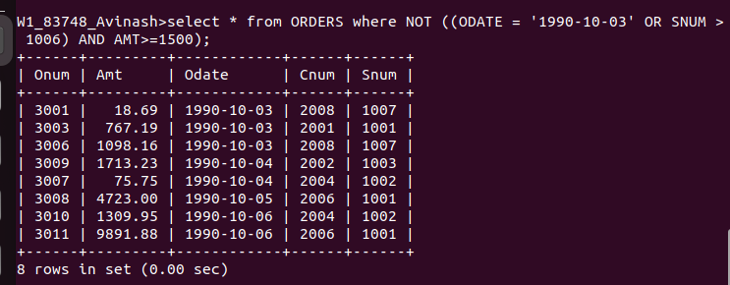

6. What is a simpler way to write this query?
Select snum, sname, city, comm From Salespeople
where (comm > .12 OR comm <.14);



